**DAILY ONLINE ACTIVITIES SUMMARY**

|  |  |  |  |  |
| --- | --- | --- | --- | --- |
| **Date:** | **27-05-2020** | **Name:** | **Latika Kavoor** | |
| **Sem & Sec** | **4th Sem & A-Section** | **USN:** | **4AL18CS035** | |
| **Online Test Summary** | | | | |
| **Subject** | **OOC** | | | |
| **Max. Marks** | **30** | **Score** | **25** | |
| **Certification Course Summary** | | | | |
| **Course** | **Introduction to Cyber Security** | | | |
| **Certificate Provider** | **ICT Academy - CISCO** | **Duration** | | **30 hrs** |
| **Coding Challenges** | | | | |
| **Problem Statement:** In Bubble sort, each pass consists of comparison each element in the file with its successor (i.e. x[i] with x[i+1]) and interchanging two elements if they are not in the proper order. The array may be sorted in any pass. If the array is sorted, then remaining passes should be skipped off. Write a C Program to sort an array of integers in ascending order and display the sorted array and Number of passes performed for sorting. | | | | |
| **Status:Completed** | | | | |
| **Uploaded the report in Github** | | **Yes** | | |
| **If yes Repository name** | | <https://github.com/alvas-education-foundation/latika.kavoor/tree/master/coding_solutions> | | |
| **Uploaded the report in slack** | | **Yes** | | |

Online Test Details: (Attach the snapshot and briefly write the report for the same)

Took the OOC IA2 test on 27-05-2020 from 9:15 to 9:45

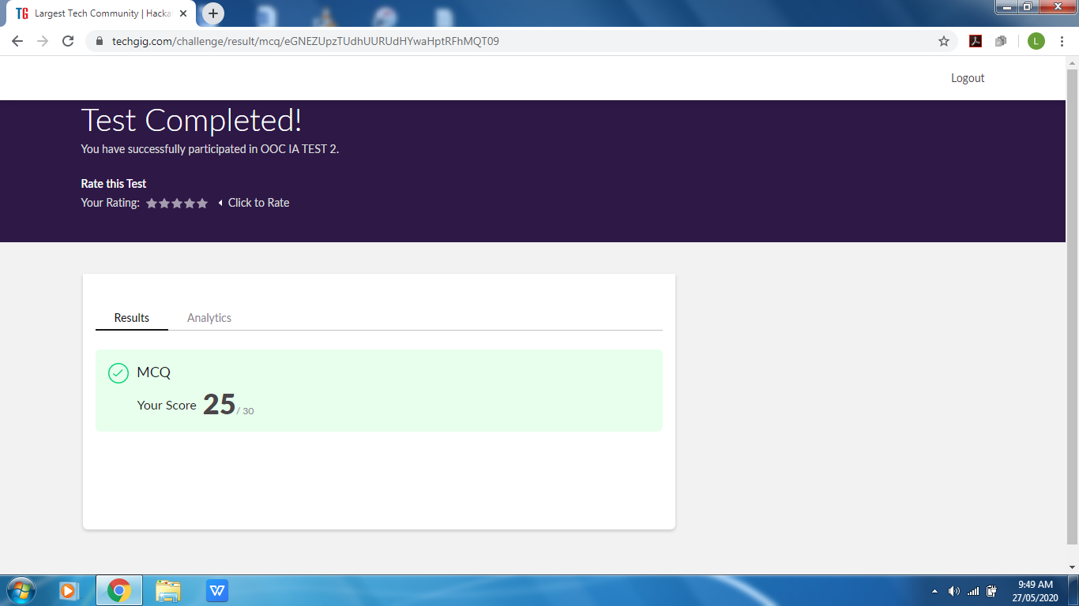

Certification Course Details: (Attach the snapshot and briefly write the report for the same)

Completing the online certification course of Cyber security.Started with the 4th chapter. Its about Cryptography.

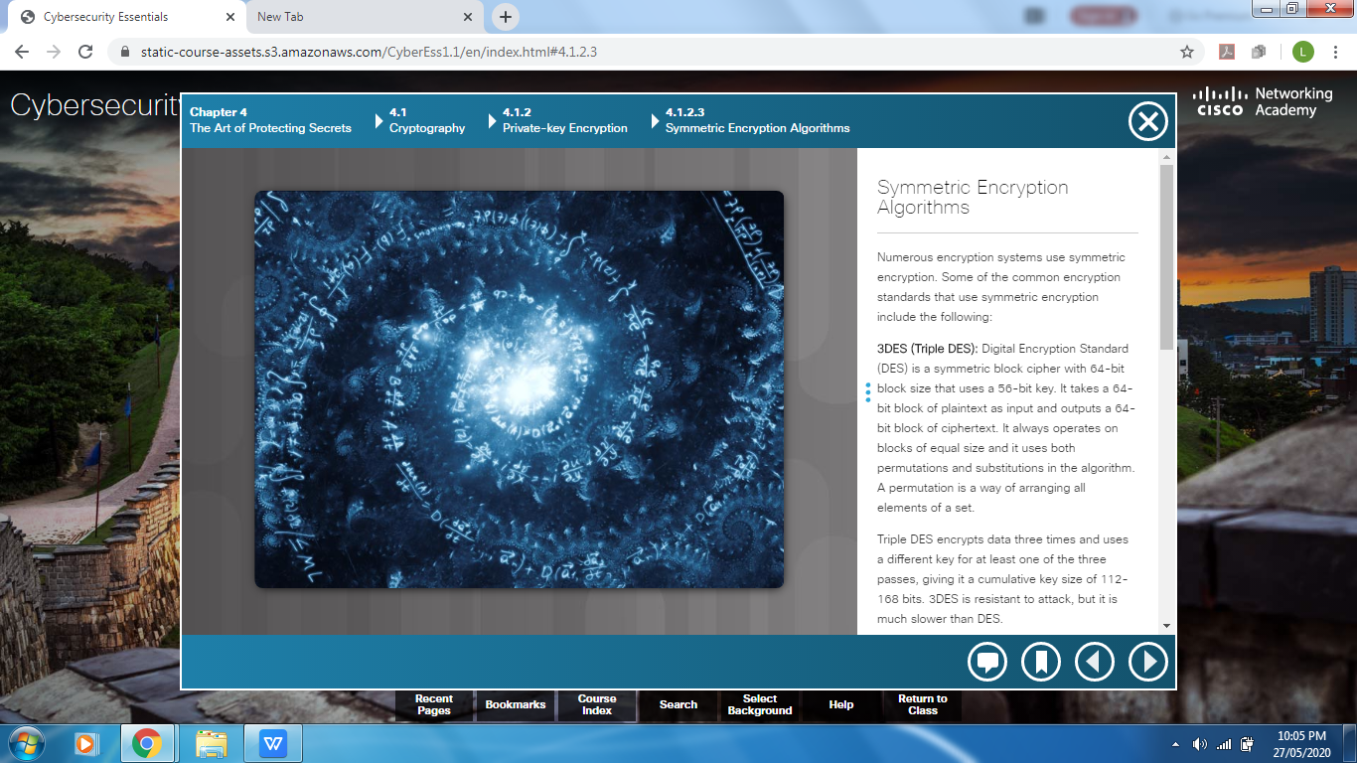

Coding Challenges Details: (Attach the snapshot and briefly write the report for the same)

Solved the problem given and uploaded it on github

